Tutorial Sheet 1 (Class Work)

- For the circuit in Fig.1(a), find voltages v1 and v2 using KVL
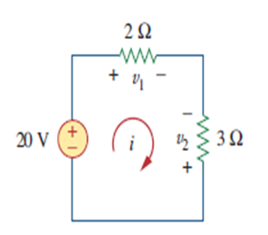

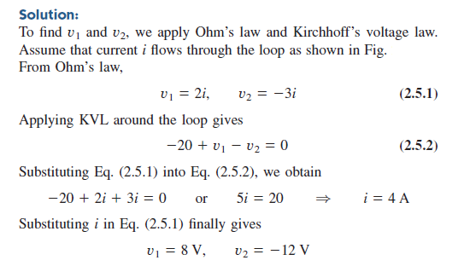

- Find the value of current I using KCL

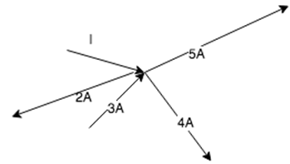

Explanation: At the junction, I-2+3-4-5=0. Hence I=8A.

- Find the values of currents i1 and i2 using KVL

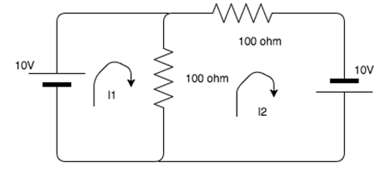

Solution: Using KVL in loop 1, 10-100i1+100i2=0
Using KVL in loop2, -200i2+100i1+10=0.
Solving the equation i2= 0.2 A and i1= 0.1A.

- Find the Current in the Resistance R2
R1=2Ω, R2=4Ω, R3=1Ω, Is=5A
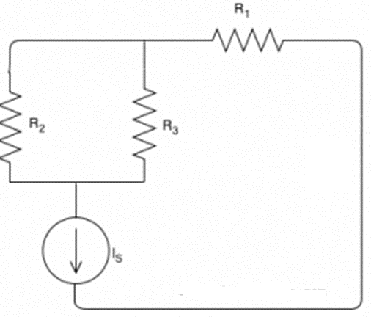
Solution: Is current is the total current divided among R2 and R3 resistance so we can apply current division rule.
Therefore, current in R2 branch = 1x5/5 = 1Ampere.

Q5. Calculate the voltage across the 10-ohm resistor
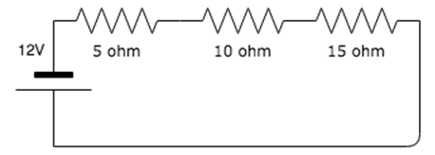

Solution: Explanation: Total resistance = 5+10+15 = 30 ohm. Current in the circuit is 12/30 A.
Voltage across 10-ohm resistor is 10*(12/30) = 4V.

Home Work

- Find the value of Current I and voltage across 30ῼ resistance in the given Figure below

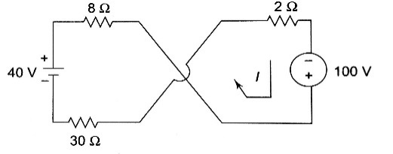

- Calculate the value of V1 and V2.

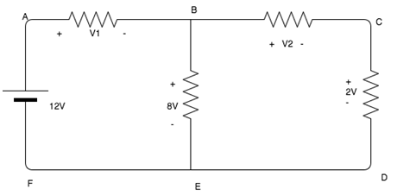

- Using Kirchhoff’s voltage law find the value of current I

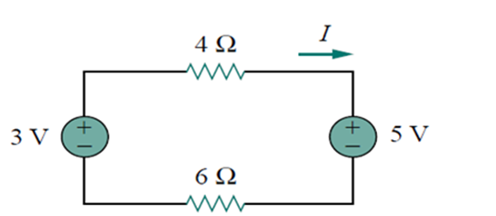

- Calculate the current across the 20-ohmw resistor.

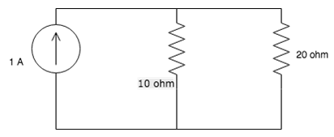

- Calculate the value of I3, if I1= 2A and I2=3A.

